Upside Down Magic Discussion Questions
Name:______________________Teacher________________________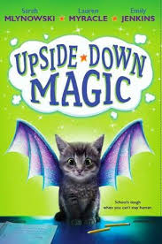

1. Why doesn’t Nory feel like she fits in with her
family? Discuss ways that you are similar to and
different from the members of your family.

2. Describe Nory’s first meeting with Pepper. Think
of a time you had an awkward first meeting.
How did the relationship work out?

3. The students in the Upside-Down Magic class all
have wonky magic. Which magic do you think
is the wonkiest? Which wonky magic would you
want to have?

4. Part of developing Upside-Down Magic is
learning to understand, not control, feelings.
How could this advice be helpful to people
without magic?

5. Ms. Starr says that unusual magic was valued
in the past. Why do you think people’s opinions
changed? Might their opinions change again?
Explain.

6. Aunt Margo does not think Nory and Elliott
should try to move out of the UDM class. She
says, “Just be who you are, not who you think
you should be.” Do you think that is good
advice?

7. After Elliott does well on his test, he runs back
to the Sparkies. Were you surprised he went
back to kids who were mean to him? Why or
why not?

8. How does the wonky magic of the UDM
students save a fellow classmate?

9. Do you think Principal Gonzalez made the right
decision about the class placement of Nory and
Elliott? Why or why not?

10. How does Nory feel about her Upside-Down
Magic in the beginning and the end of the
book?

Alternative Project

Create a drawing of your upside down magic.

