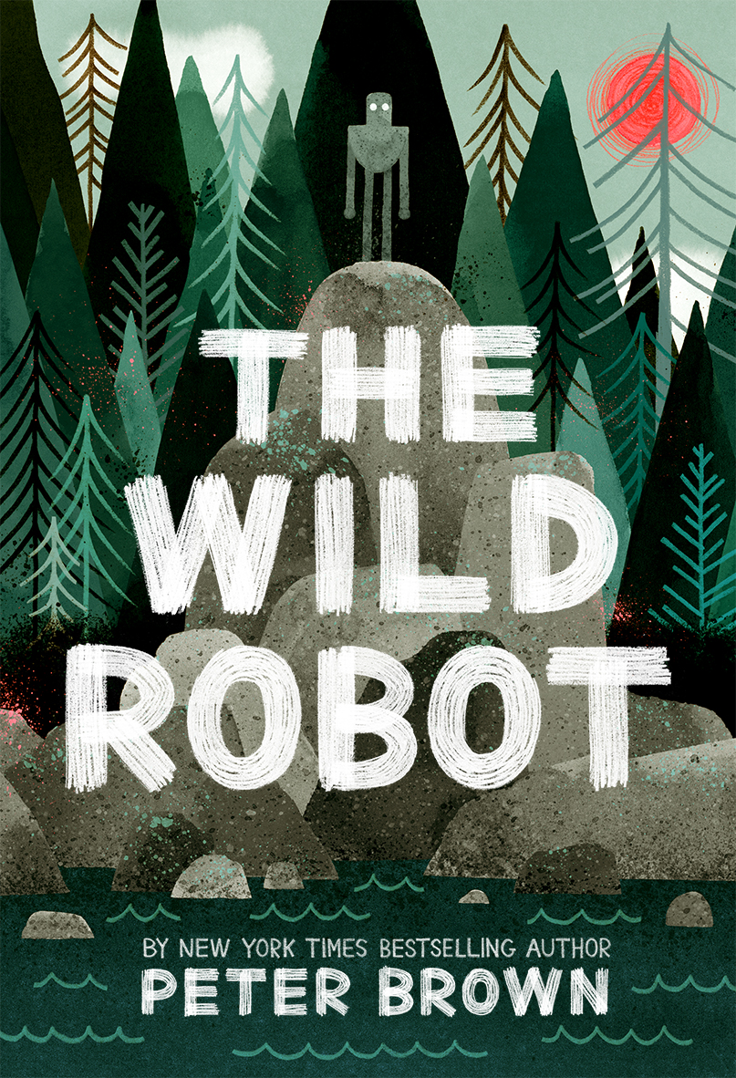
THE WILD ROBOT by Peter Brown

- How did Roz come to be at the island? What did she have to do to get herself acquainted with her new surroundings?

- Roz had to use many skills to survive. What do you think was her best survival skill?

- Towards the beginning of her time on the island, the animals saw Roz as a monster. What changed their attitude towards her?

- Even though we didn’t like reading about the young bears attacking Roz, is that how you’d expect wild animals to react? Why or why not? What other animal behaviors that you read about would be what you’d expect from a “wild” island habitat? Which behaviors weren’t normal actions/reactions from nature?

- Brightbill and Roz ended up as an unlikely family. How did they act much like a traditional family? How were they untraditional? What tragedy brought them together? Can good things come from tragedy?

- Peter Brown made a point to tell us as readers that Roz could not feel emotion. Do you think she eventually learned how to feel and developed emotion or was she simply reacting and adapting to her experiences as her programming wished her to do? Do you think it’s possible that robots like Roz in real life might have the ability to learn, develop, and have emotions? Explain.

- Roz learned from the island, but how did the “island” learn from Roz? What lesson/moral do you think Peter Brown wanted us readers to get from The Wild Robot. Explain your thinking.

- Once they RECOs came, they “saw” Roz as defective. Why? What was she doing to make them think that? Why do you think the RECOs were so insistent that Roz could not stay at the island? Did the Makers really need every single robot back? Why or why not?

- What do you think happens to Roz once she returns with the ship? How do you think the Makers will react? Do you think she will eventually be able to find her way back to the island? Explain.

- Think of all of the science and technology Peter Brown has in the book. Which technologies are real and which ones haven’t become “everyday” just yet?

Alternate Projects/Activities

Read Peter Brown’s Author’s Note and Blog Post and report out on how he came to write The Wild Robot. http://www.peterbrownstudio.com/uncategorized/the-wild-robot/#.WCSggOErLq1

Create a short research project on the possibilities of Artificial Intelligence in Robots. Be ready to report out on your findings. (Try to include information on why it’s a controversial topic, too, if you can!)

Create and design your own robot. What would it be capable of? What would its limitations be? Come with a picture/model and make sure you have its characteristics noted.

Questions/Alternate projects written by R.Meisinger 2016

