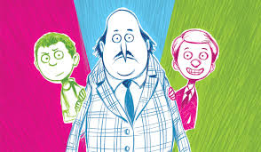
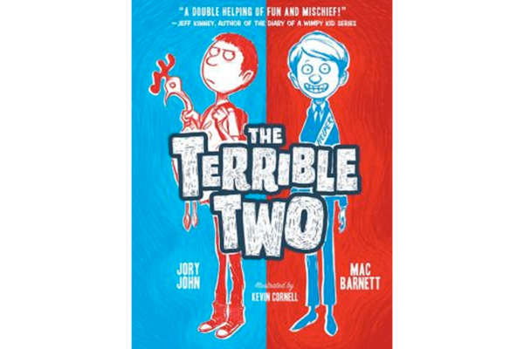
Name _________________________ Teacher___________________

The Terrible Two – Mac Barnett and Jory John

- On p.12, Miles tells the reader, “On your first day at a new school in a new town, you get to decide what kind of kid you want to be…Chess kid, basketball kid, student-government kid…” Do you agree with this? Do you think you have to decide to be one kind of kid? Why or why not?

- Why were Miles and Niles an unlikely team? Why did they work well together?

- Why was the principal of Miles’s new school so suspicious of him? Why did he not suspect Niles?

- Even though other students think he’s a weasel, Josh is voted the class president because he runs unopposed until Holly starts running as a protest candidate. What is a protest candidate? Do you think this is an effective strategy? What else could Holly or the other students do to try to remedy this situation?

- On p.92-93, Miles starts to admit to himself that his closest friends weren’t talking to him anymore because of his pranks. What other negatives could come from pranking?

- What was with all of the cows? How do Mac Barnett and Jory John use the cows and facts to lead up to the ending of the book?

- What did you think of Miles and Niles’s decision to place the blame for their final prank on Josh?

- Would you ever prank someone? How do you think it feels to be a victim of a prank?

- Is there such a thing as a prank that goes too far?

- What was your favorite prank? Worst prank?

Alternative Projects

Make your own Pranking Notebook: http://www.abramsbooks.com/pdfs/academic/terrible_two_activities.pdf

Compare and contrast Miles and Niles. Try to use character traits and any other images to help make your diagram as detailed as possible.

